NPTEL WORKSHOP – ANALOG LAB
Wadhwani Electronics Laboratory
Electrical Engineering Department, IIT Bombay

DAY 2 LAB REPORT
Op-Amp Based Circuits

Name: Sahil Ingale
1. Precision Rectifiers
Supply: ±15 V. Op-Amp: TL072 (or μA741). Diodes: 1N4148 (fast switching). R₁ = R₂ = 10 kΩ, R_L = 1 kΩ.
Input: Vi = 10 Vpp, 1 kHz sinusoid.

1.1 Half-Wave Precision Rectifier
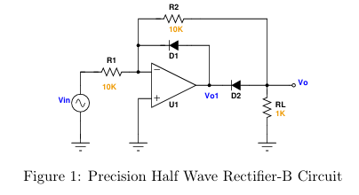
Circuit Working Principle
Positive half-cycle (Vi > 0): The Op-Amp output Vo1 goes positive. D2 is forward-biased, D1 is reverse-biased. The circuit acts as an inverting amplifier with gain −R2/R1 = −1. Thus Vo = −Vi (inverted positive half).
Negative half-cycle (Vi < 0): The Op-Amp output goes negative. D1 conducts (feedback), D2 is cut off. Virtual ground is broken; Vo1 = −Vsat, and the output Vo = 0 (D2 blocks).
Key advantage over ordinary rectifier: The diode voltage drop (0.6–0.7 V) appears inside the op-amp loop and is divided by the open-loop gain (~200,000 for 741). Effective threshold ≈ 0.7/200,000 ≈ 3.5 μV — negligible. Useful for rectifying millivolt-level signals.

Measured Observations — Half-Wave Precision Rectifier
Figure 1: Half-Wave Precision Rectifier — Vi (Ch1), Vo1 (Ch2), Vo (Ch3) vs. time
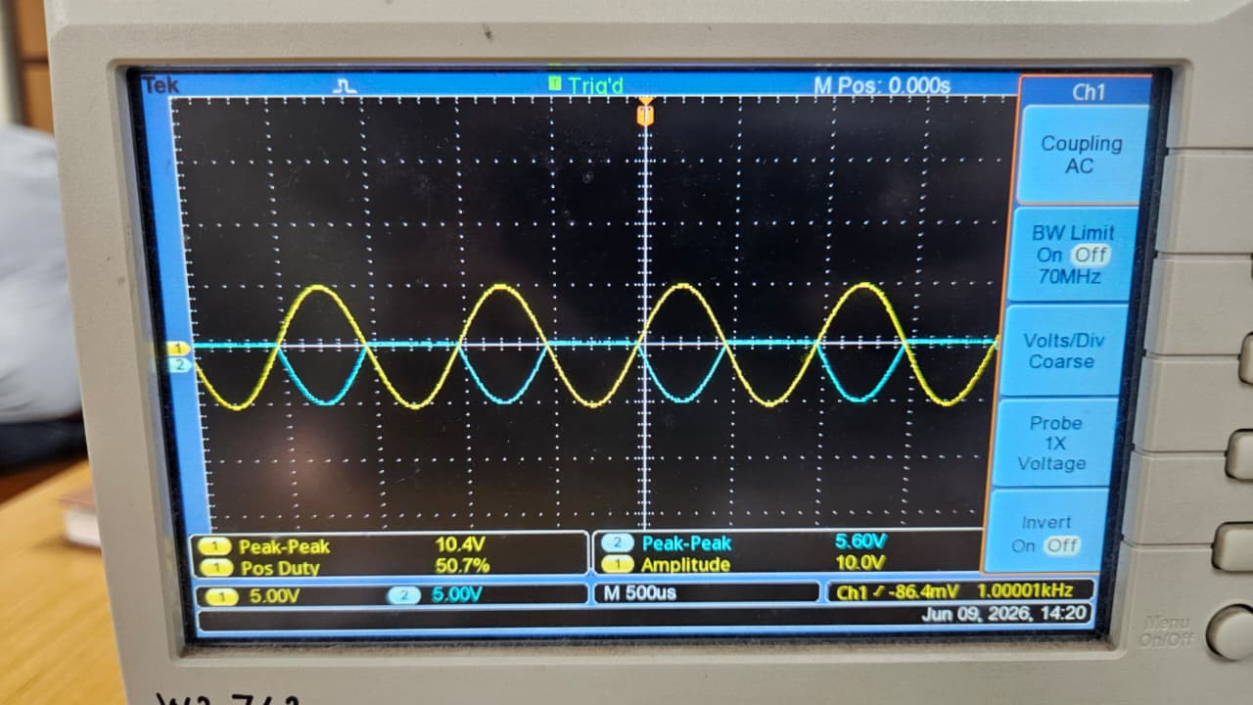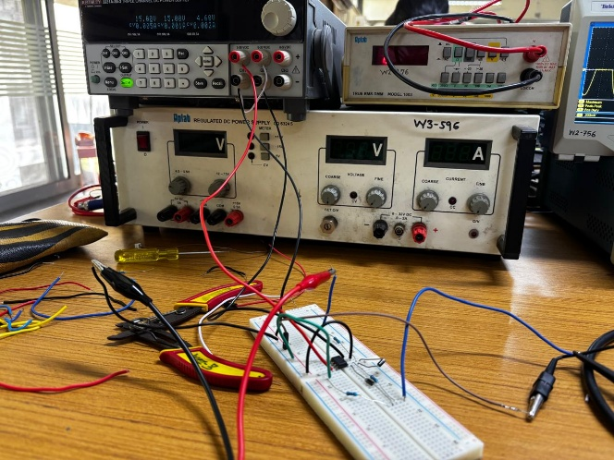

Measured Vo,peak: 5.2 V
1.2 Full-Wave Precision Rectifier
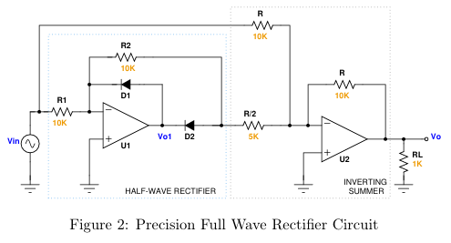
Circuit Working Principle
Stage 1 — Half-Wave Rectifier (U1): Produces the negative half-wave rectified signal at Vo1, i.e., Vo1 = −Vi for Vi > 0, and Vo1 = 0 for Vi < 0 (as in 1.1).
Stage 2 — Inverting Summer (U2): Sums Vi and Vo1 with gains set by the resistor network.
Gains: Gain for Vi through R = 10 kΩ → −R_f/R = −10k/10k = −1
Gain for Vo1 through R/2 = 5 kΩ → −R_f/(R/2) = −10k/5k = −2
Output: Vo = −(Vi + 2·Vo1 )
For Vi > 0: Vo1 = −Vi → Vo = −(Vi + 2×(−Vi)) = −(Vi − 2Vi) = Vi (positive)
For Vi < 0: Vo1 = 0 → Vo = −(Vi + 0) = −Vi (positive, since Vi is negative)
In both half-cycles Vo = |Vi|, giving full-wave rectification with negligible diode-drop error.
Measured Observations — Full-Wave Precision Rectifier
Figure 2: Full-Wave Precision Rectifier — Vi and Vo vs. time (both cycles positive)
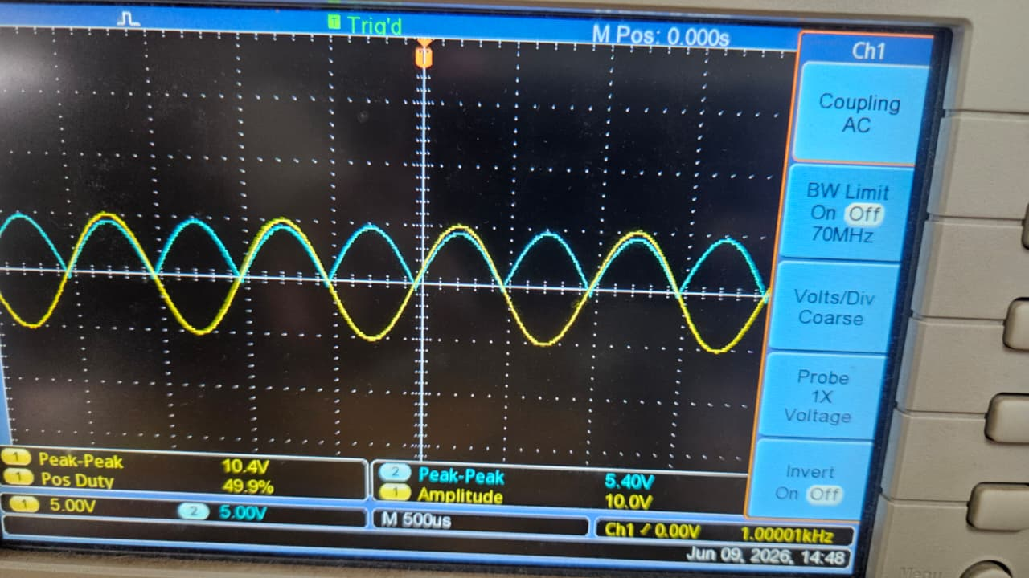

Measured Vo,peak: 5.2 V
2. Astable Multivibrator
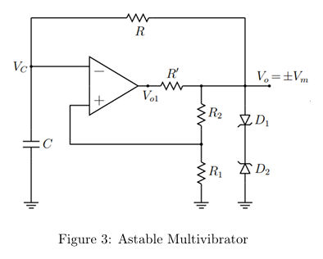
Components: Op-Amp 741, ±15 V supply, C = 0.01 μF, R = 47 kΩ, R₁ = 33 kΩ, R₂ = 39 kΩ.
Optional: R' = 1 kΩ (series with op-amp output), Zener diodes D₁, D₂ = 4.7 V.
Theoretical Calculations
(a)/(b) Without R' and Zener Diodes
The positive feedback network sets the threshold voltage fraction:
β = R₁/(R₁+R₂) = 33/(33+39) = 33/72 = 0.4583
The capacitor charges/discharges between −βVsat and +βVsat through R.
Time period: T = 2RC ln[(1+β)/(1−β)]
= 2 × 47×10³ × 0.01×10⁻⁶ × ln[(1+0.4583)/(1−0.4583)]
= 2 × 47×10³ × 0.01×10⁻⁶ × ln(1.4583/0.5417)
= 2 × 47×10³ × 0.01×10⁻⁶ × ln(2.692)
= 2 × 47×10³ × 0.01×10⁻⁶ × 0.9904
= 2 × 4.655×10⁻⁴ = 9.31×10⁻⁴ s ≈ 0.931 ms
Frequency: f = 1/T = 1/0.931×10⁻³ ≈ 1074.1 Hz ≈ 1074 Hz
Vo swings between +Vsat and −Vsat (≈ ±13.5 V for 741 with ±15 V supply).
Vc (capacitor voltage) swings between −βVsat and +βVsat ≈ ±6.19 V as an exponential.

Figure 3: Astable Multivibrator — Vc (Ch1) and Vo (Ch2) vs. time (no R', no Zener)
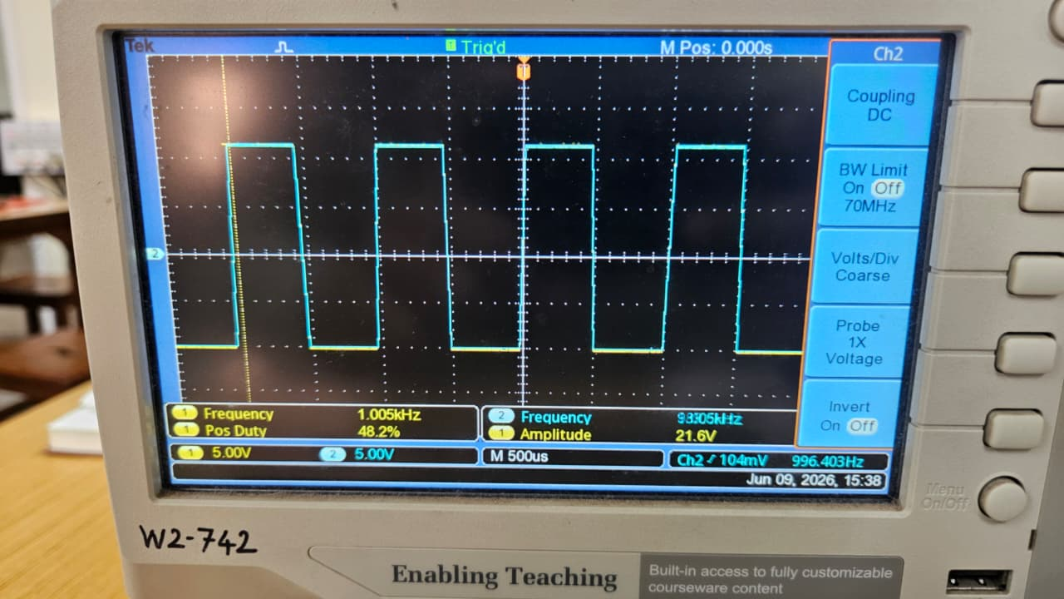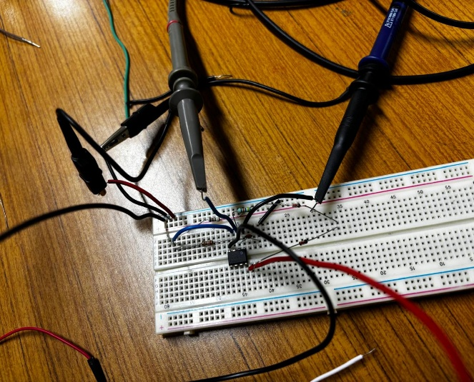
(c) Frequency at Vo (without R' and Zener)
Calculated frequency ≈ 1074 Hz. Measured: 996 Hz
(d)/(e)/(f) With R' = 1 kΩ and Zener Diodes (4.7 V)
Effect of R' = 1 kΩ:
- R' is in series with the op-amp output before the R₁–R₂ feedback divider. It slightly reduces the feedback voltage reaching the divider, but since R' << R₁ (1 kΩ << 33 kΩ), the effect on frequency is minor.
- R' protects the op-amp output from the zener diode current surge.
Effect of Zener Diodes:
Vo1 (pre-zener) saturates at ±Vsat ≈ ±13.5 V.
Vo (post-zener) is clipped to ±Vm = ±(Vz + Vf) = ±(4.7 + 0.7) = ±5.4 V
The voltage levels ARE different: Vo1 ≈ ±13.5 V, Vo ≈ ±5.4 V.
Reason: The back-to-back zener diodes clamp the output. For positive Vo1, D1 is forward-biased (0.7 V) and D2 is in reverse breakdown (4.7 V), giving Vo = 4.7 + 0.7 = 5.4 V. Vice versa for the negative swing.
Frequency change: The frequency is essentially unchanged because the RC time constant is determined by R, C, and β — none of which are altered by R' or the zener diodes. Any small change is due to R' slightly modifying the effective feedback ratio.
Expected f with zeners ≈ 1074 Hz (same as without zeners)

Figure 4: Astable Multivibrator with Zener diodes — Vo1 (Ch1) and Vo (Ch2) vs. time

3. Measurement of Offset Voltage and Bias Currents

IC used: μA741. Supply: ±15 V.
Datasheet typical values (LM741C): VOS(typ) = 1 mV, VOS(max) = 6 mV, IB(typ) = 80 nA, IB(max) = 500 nA.
3.1 Measurement of Input Offset Voltage (VOS)
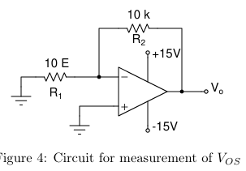

Figure 5: VOS measurement circuit — Vo on DMM / DSO (Vin = 0)
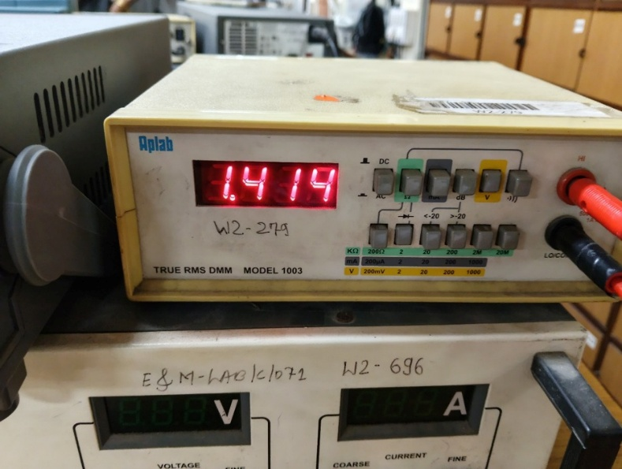

3.2 Measurement of Inverting Input Bias Current (I⁻B)
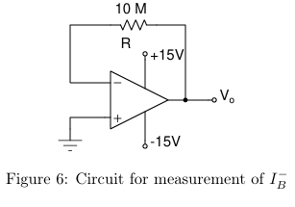

Figure 6: I⁻B measurement — Vo on DMM
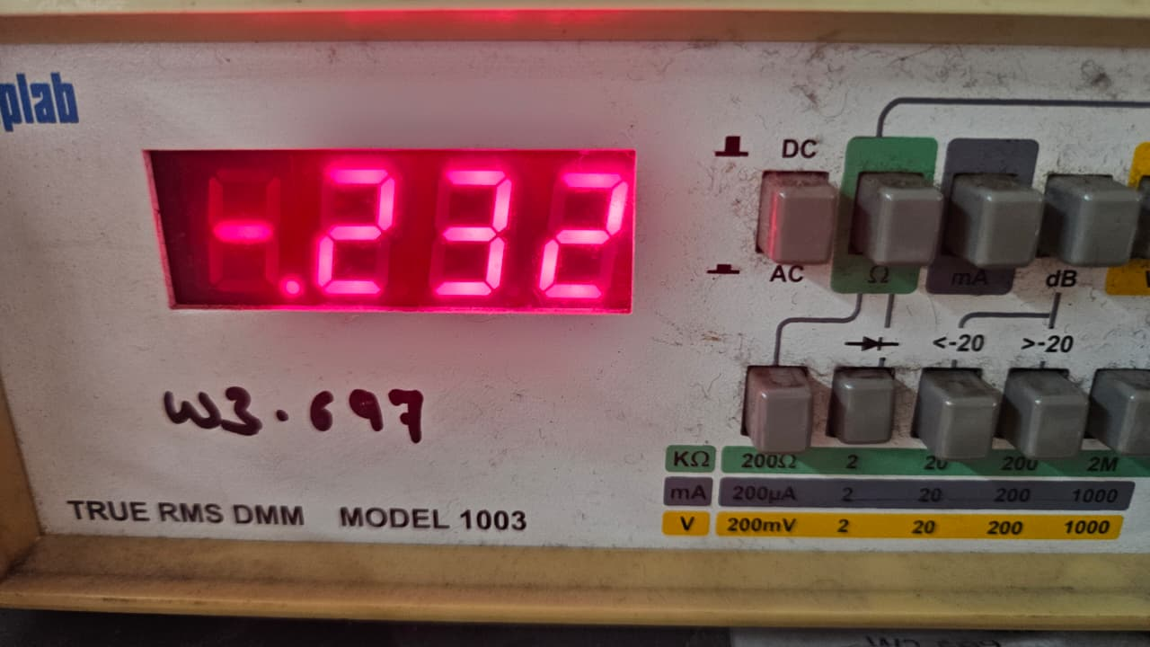
3.3 Measurement of Non-Inverting Input Bias Current (I⁺B)
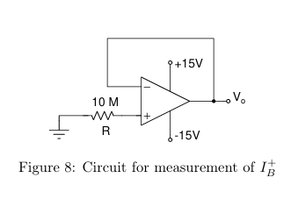

Figure 7: I⁺B measurement — Vo on DMM
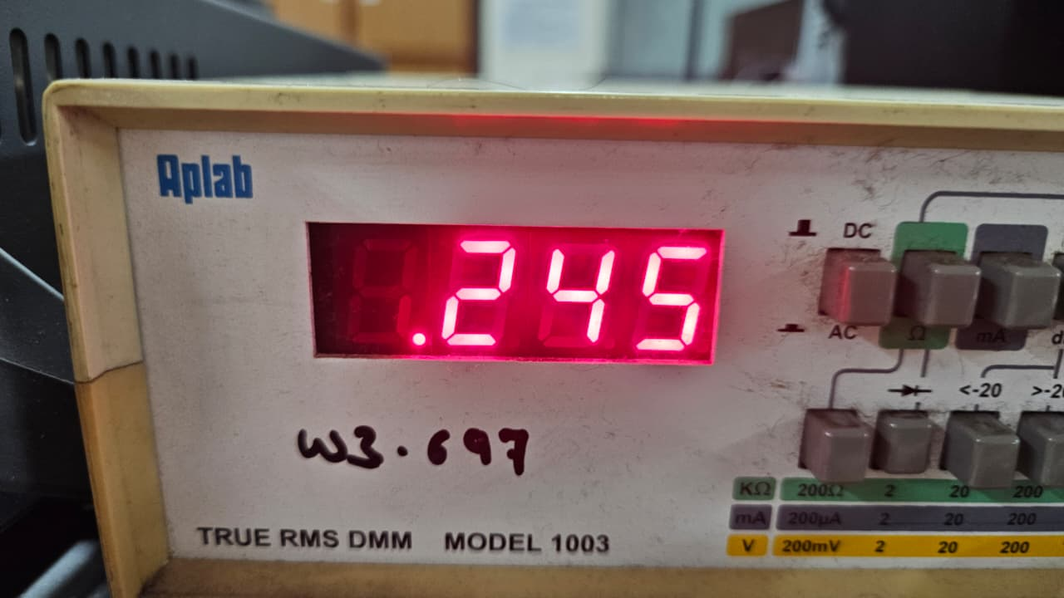

4. Input Offset Voltage Compensation Using Offset Null Pin
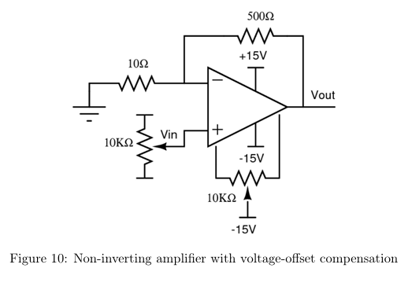

Figure 8: Offset null procedure — Vout before and after compensation (Vin = 0)
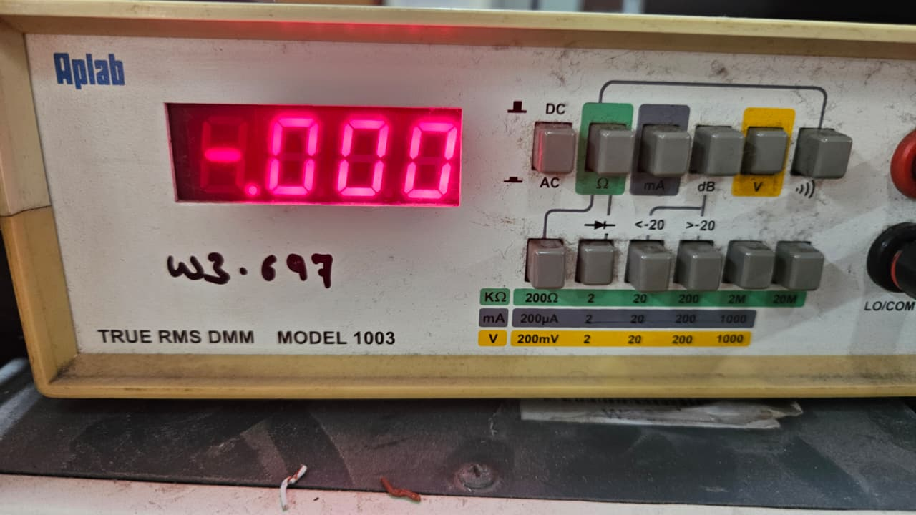

4(b) Vin ≈ 10 mV
Figure 9: Offset compensation comparison — Vin = 10 mV with/without pot
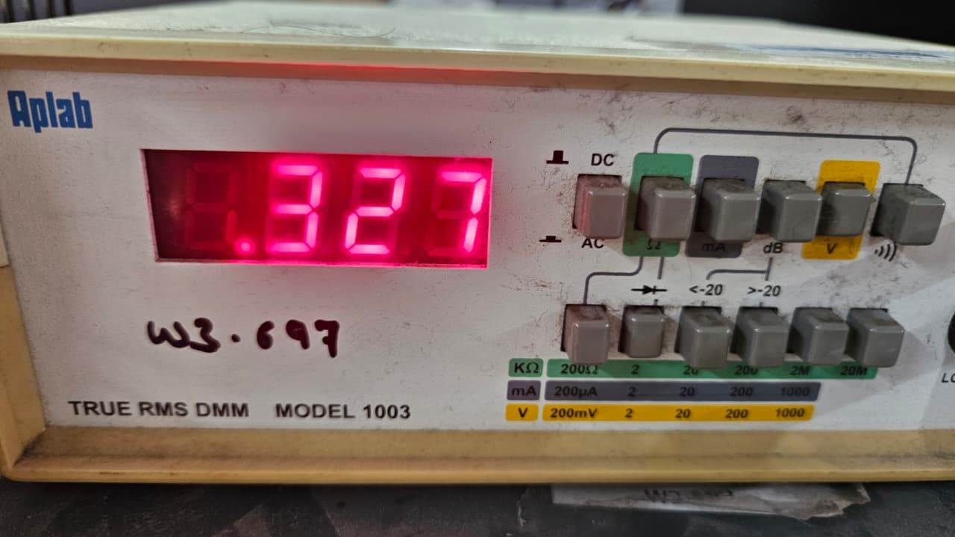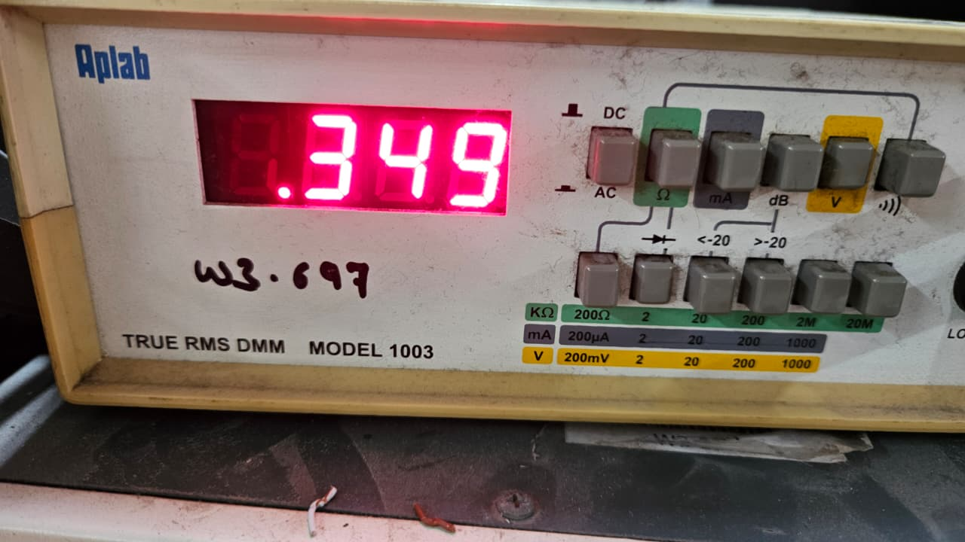

4(c) Vin ≈ 30 mV

Figure 10: Offset compensation comparison — Vin = 30 mV, with/without pot
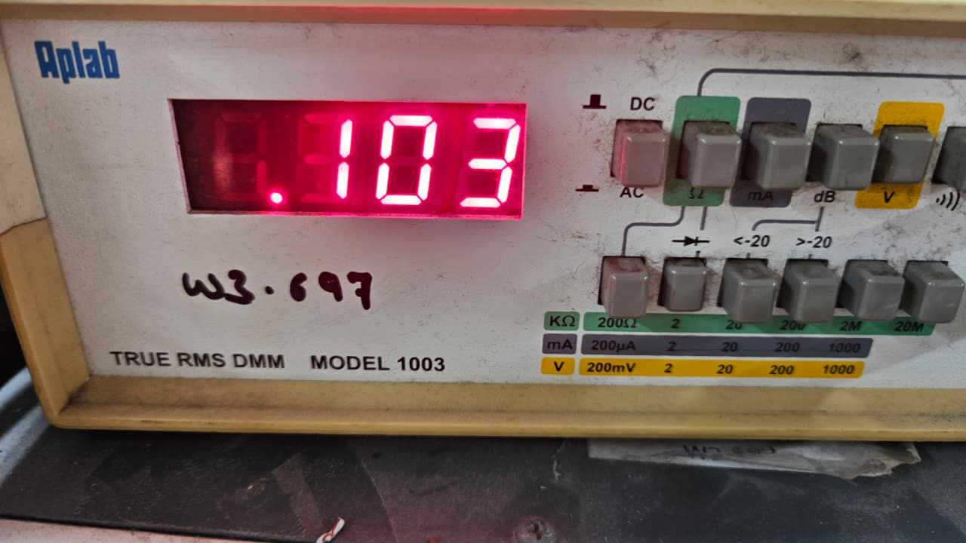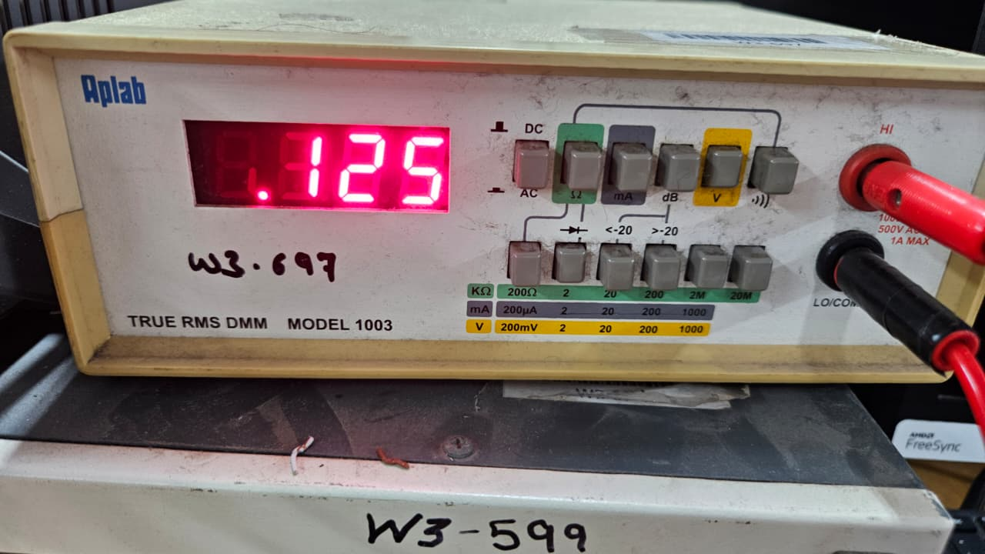

4(d) Observations and Explanation
With offset compensation: The output closely follows the ideal gain equation Vout = 51 × Vin. The potentiometer injects a small corrective current into the op-amp's internal differential stage (via pins 1 and 5), cancelling the inherent mismatch between the two input transistors.
Without offset compensation: The output includes an additive DC error equal to VOS × Gain. For a 1 mV offset and gain of 51, this is 51 mV of DC error — significant for low-level signals (e.g., 10 mV input).
At higher input levels (30 mV), the percentage error decreases because the signal-to-offset ratio improves. However, the absolute error remains the same.
Conclusion: Offset compensation is critical in high-gain DC amplifiers, sensor signal conditioning, and precision measurement circuits.
Conclusion
- The Precision Half-Wave Rectifier successfully rectified small-amplitude signals by enclosing the diode within the op-amp feedback loop, eliminating the 0.7 V threshold limitation.
- The Precision Full-Wave Rectifier, combining a half-wave stage with an inverting summer (gain = −2 for the rectified path and −1 for Vi), produced |Vi| at the output with no dead zone.
- The Astable Multivibrator with C = 0.01 μF, R = 47 kΩ, R₁ = 33 kΩ, R₂ = 39 kΩ produced a square wave at 1074 Hz. Adding Zener diodes clamped the output to ±5.4 V without changing the frequency.
- VOS was measured using a high-gain (×1001) circuit. The calculated VOS (= Vo/1001) should be within the 741 datasheet spec of 1–6 mV.
- Bias currents I⁻B and I⁺B were measured using a 10 MΩ resistor at the respective input. Results should fall within the 741 typical spec of 80 nA.
- Offset null compensation using the 10 kΩ potentiometer on pins 1 & 5 of IC 741 effectively reduced output error to near zero, validating the importance of offset compensation in precision amplifier circuits.

